Community Connections Mentoring
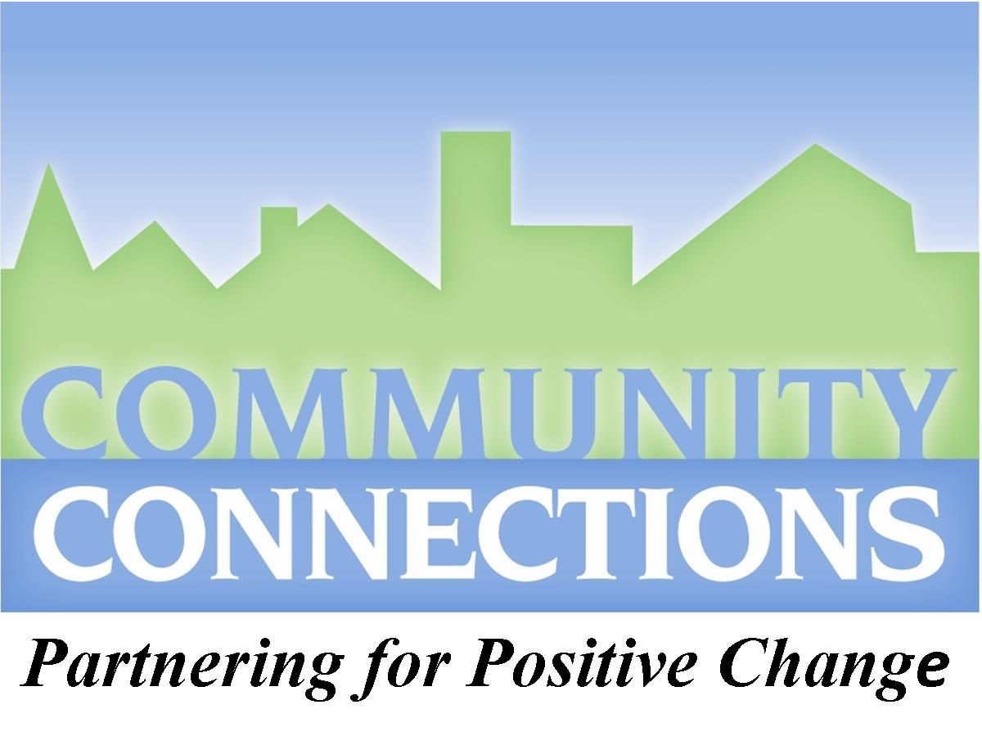
makes a difference.
Be someone who matters – to someone who matters!
Thank you for your willingness to be a mentor. This can be a very rewarding experience for you, and an opportunity to make a substantial difference in the life of a child.
(308) 696-0975
mentor@communityconnectionslc.org

Brief Description

Community Connections mentoring matches children in kindergarten through seventh grade with adult mentors (18 or older) with similar interests. A mentor is a role model, and someone to listen to, and encourage the child.

You will spend one-on-one time with your mentee doing activities you both enjoy. Our program offers monthly group activities to give you options for time spent together. Past activities have included art classes, game nights, playing disc golf, touring KNOP TV, horseback riding, and many others. We also have community service projects for our mentoring pairs to participate in. Some examples include helping at 5k events, baking cookies for others, and raking leaves for elderly.

As a mentoring pair, you will receive free admission to the North Platte Recreation Center and Children’s Museum. Bi-monthly, we provide a newsletter of activities and other information.

FAQs about mentoring:

- Do you pick the youth for me? How are we matched?
You are an essential part of the matching process. You will have an opportunity to learn about a potential mentee, before we match you with someone. We want our matches to be successful.

- If I have children can I include them in our time together?
Yes, as long as you also have an opportunity to meet one-on-one with your mentee.

- Where will I meet with my mentee?
Our mentoring program is community based, with the flexibility of meeting at any of your favorite locations in Lincoln County. There are many public locations, such as parks, museums, etc., that provide the opportunity to spend time with your mentee. You are also welcome to meet with your mentee during his or her school lunch period. You can meet with your mentee any time that works for you and the child.

- I am worried that I won’t have enough time to spend with my mentee.
Mentees do not expect you to always make special plans for them. They just enjoy the fact that you think they are special enough to be with them. Letting them go with you during your normal routine is an easy way to get to know them, and teach them a lot of life lessons, even including them when you run errands, can be a great way to develop a relationship.

Minimum Mentor Requirements

- Be at least 18 years old, and have a desire to make a positive difference in the life of a child.
- Be a good role model for youth, free of illicit drugs. Not have mental or physical problems that interfere with your ability to be a good mentor.
- Be able and willing to make a one year commitment to the program, and spend 4 to 8 hours per month with the child, which may include the monthly group activities.
- Be willing to maintain regular contact with Community Connections staff, report mentoring hours and let staff know of address and other changes.
- Be willing to participate in mentor trainings and complete yearly surveys about the mentoring program.
- Be able to provide your own transportation (valid driver’s license and liability insurance).
- Pass a criminal background check and Health & Human Services registry check.
- Be able to provide references as evidence of your character and ability to be a good mentor.
- Be willing to follow the confidentially, ethics and other guidelines of the program.

Steps to Becoming a Community Connections Mentor

- Complete the application and return it to: Community Connections Mentoring
PO Box 852, North Platte NE 69103
or bring it to 121 N Dewey to our downtown location

- We will contact you for an interview/orientation meeting, in which we will:
learn more about your interests and personality to help us match you with a child, answer your questions and any concerns you have, and give you additional information to get started.

- We will check your references and ensure that background checks are completed. We reserve the right to verify the information in your application. Application material is confidential and becomes the property of the agency. We will provide a mentor training manual and review the contents in a training session individually or as a group.

- We will select a child as a potential match with you. We will tell you about the child (age, interests, personality) and get your approval for a match. We will share similar information about you, with the child’s parents. If it seems right to everyone, we will continue. If not, we will talk with you about a different child.

- You will meet with the child, the child’s parent(s) and Community Connections Mentoring staff for a get-acquainted session and final agreement for a match.

- You will embark on what we hope will be a positive, life-enriching experience for you and your mentee.

Continuing on, as a mentor:

We will be available to address any concerns you have. We will send you regular newsletters about group activities, etc. We have one or two group activities each month. Periodically, we will have informal training sessions for you and other mentors. Each month you will report your hours. You will keep us informed of any concerns, address changes, etc.
Mentor Application

Please complete the following information so that we are able to better pair you with a mentee.
Personal Information:
Name: |  |  |  |  | Date:
Race/Ethnicity: |  | Sex: |  | Date of Birth: | Marital Status:
Home Address: |  |  | Home Phone: |  | Cell Phone:
Do you regularly use email?  YES NO | Email Address:

Volunteer Eligibility: You must be able to answer YES to each of the following criteria in order to be eligible. Please initial each criterion below:
____ I’m at least 18 years old.
____ I reside in Lincoln County, NE.
____ I am willing to adhere to Community Connections policies and procedures.
____ I agree to a one-year commitment to the program.
____ I can commit to spending an average of 4 to 8 hours a month with the mentee.
____ I can complete the screening process.
____ I have a clean criminal history:
____ I have never been arrested, charged, or convicted of a crime against a child.
____ I am not a convicted felon.
____ I understand that I will undergo a background check prior to being matched with a child.
____ I understand that I will undergo a background check every two years.
____ I understand that all of my references listed in this application will be contacted.
____ I will attend mentor trainings.
____ I am willing to communicate regularly with mentoring staff, and submit monthly time
spent on mentoring.
____ I have access to reliable transportation, a valid driver’s license, proof of liability
insurance in which I maintain.
____ I do not use illicit drugs.
____ I will not use alcohol or tobacco in the presence of mentees.
____ I do not use controlled substances unless prescribed.
____ I have not been hospitalized for a mental disorder in the past three years.
____ I have not falsified information during the screening process.

Employment Information:

Employer (If retired, former employer): |  | Occupation: |  | How Long?
Immediate Supervisor: | Position:
Work Address: |  |  | Work Phone Number:

How did you hear about Community Connections Mentoring?
_____________________________________________________________________________________

What made you decide to become a mentor? ____________________________________________

_____________________________________________________________________________________

What strengths do you bring to the mentoring process? ______________________________________
_______________________________________________________________________________________

What are your expectations of a mentoring relationship? _______________________________________________________________________________

Do you have any guns and/or ammunition in your home or vehicle? Yes No
(if yes, we will discuss safety precautions when we meet in person)

Do you have any medical conditions that would impact a relationship with a mentee? Please explain and include any accommodations that are requested.
_______________________________________________________________________________________________________________________________________________________________________________

Please list any medications that you are currently taking: _________________________________________________________________________________________________________________________________________
Have you ever been treated for any mental health concerns? Yes No
If you answered yes, please explain ___________________________________________________
________________________________________________________________________________
Have you ever been terminated from a volunteer position? Yes No

__________________________________________________________________________________________

Have you ever been arrested or convicted of a crime? If so, what were the circumstances?
________________________________________________________________________________________________________________________________________________________________________________________________________________________________________________

Are you involved in any church or community organizations, and if so, which ones? ________________________________________________________________________________________

Are there any people you can recommend for us to contact to be potential mentors?
Name/Address/Phone: _________________________________________________________________________________________________________________________________________________

Please list all members of your immediate household.
Name Sex Age Relationship to applicant
_________________________ ____ _____ _____________________

_________________________ ____ _____ _____________________

_________________________ ____ _____ _____________________

_________________________ ____ _____ _____________________

_________________________ ____ _____ _____________________

Please read this carefully before signing:
By signing below, you attest to the truthfulness of all information listed on this application. You agree to let our program confirm all information listed and to conduct a federal and state criminal records check.

Please initial the following:
___I agree to follow all mentoring program guidelines and understand that a violation will result in suspension or termination of the mentoring relationship.
___I understand that Community Connections Mentoring Program is not obligated to provide a reason for a decision to reject me as a mentor.
___ (optional) I agree to all Community Connections Mentoring to use any photographic image of me taken while participating in the mentoring program. These images may be used for promotions or related marketing materials.
___ If selected, I will follow the rules of the program and be a dedicated mentor. I agree to the time commitment of 4 to 8 hours per month for a minimum of twelve months.

___________________________________________________________ ____/____/____
(Signature) (Date)

Car Insurance Policy

To ensure the safety and security of our students, agents, employees, officers, members, or representatives we require all persons transporting persons within our group to have current car insurance. (You will be required to provide proof of insurance)

I, _____________________________________________, a representative of Community Connections mentoring program agree to have current car insurance. I also agree to notify the program coordinator if my driving status or insurance changes, within 72 hours of the change.

________________________________________ __/____/____
(Signature) (Date)

Release of Information

I, __________________, understand that it will be necessary for Community Connections Mentoring Program to conduct a background check regarding my criminal history, personal references and employment.

I authorize them to obtain any needed information regarding my legal/criminal history, character references and employment from any state or federal agency, my employer, and personal references for the purposes of participating in a mentoring program. Further, I provide Community Connections to conduct the same investigation of my background in previous state in which I have resided.

Further, I understand that information about myself will be anonymously (without my name) shared with a prospective mentee(s) and his/her parent(s)/guardian(s) to aid in determining a suitable match. Once a mentor/mentee match is determined, my identity and any other information may be shared with the mentee and the appropriate adults in his family in order to facilitate a safe and successful match.

_________________________________ Date________________________
Signature
Please list any other cities, states and dates of residency during the past 10 years.
_______________________________ ________________ ______________ ___________
City State from (m/yr) To (m/yr)
_______________________________ ________________ ______________ ___________
City State from (m/yr) To (m/yr)
_______________________________ ________________ ______________ ___________
City State from (m/yr) To (m/yr)
_______________________________ ________________ ______________ ___________
City State from (m/yr) To (m/yr)
Mentor Interest Survey

Circle all activities you enjoy:

Arts/Crafts | Fishing/Outdoor sports | Soccer
Animals | Gardening | Spiritual
Auto Repair/Mechanics | Horseback Riding | Tennis/Racket Sports
Board Games/Playing Cards/Chess | Library/Reading | Video Games
Basketball | Martial Arts | Volunteer Work
Baseball | Movies | Volleyball
Bicycling | Music | Water sports
Bowling | Museums/History | Soccer
Computers | Photography | Water Skiing
Cooking/Baking | Rollerblading/Skateboarding | Woodworking/Building things
Dance/Gymnastics | Running/Track
Drama/Acting | Science

List any other areas of special interest: ______________________________________________
______________________________________________________________________________
______________________________________________________________________________

How would you feel about mentoring a child whose culture, values, lifestyle or behaviors are different from yours? ____________________________________________________________

______________________________________________________________________________

______________________________________________________________________________

List the types of things that “push your buttons” and how you deal with them. ______________________________________________________________________________
__________________________________________________________________________________________________________________________________________________________________________________________________________________________________________

Being a mentor, there are some things you MAY encounter for which you will not be prepared. This information helps Community Connections staff to provide training in areas of greatest concern and to pair you with a youth within your comfort range. Here is a list of issues that you MAY encounter. Please score the following with the number which best fits your comfort level in coping with the potential concerns or issues:

1 – Would accept
2 – Would accept if training in this area was provided to me
3 – Would consider
4 - Would NOT be comfortable working with this issue

A child who is or has an issue with…

___Hyperactive/Talkative ___Lacks confidence
___Quiet or shy ___Dresses differently/clothing fads
___Low activity level ___Physically challenged
___Does not respect authority ___Emotionally challenged
___Experienced abuse ___Mentally challenged
___Dishonest/Exaggerates the truth ___Poor hygiene
___Lacks good manners ___Messy home
___Struggles with school ___Lack of parental involvement
___Problems with peer’s ___Chaotic family life
___Problems with parent’s ___Extreme poverty
___Manipulation ___Court involvement
___Eating Disorders ___Parent unable to speak English
___Sexual Orientation that differ from your own ___Race that differs from your own
___Religion that differs from your own ___Absent Parent
___Identifies as a different gender or gender fluid

Community Connections Mentoring
121 N Dewey Suite 109
308.696.0975
mentor@communityconnectionslc.org
www.communityconnectionslc.org
Reference List

Please provide the name, phone number, email address and/or mailing address of three character references other than relatives. Reference feedback will be considered as a part of the application process. Please contact your references in advance to let them know someone from Community Connections will contact them. All references will be contacted, and the screening process will be delayed if there are any issues in reference feedback. NOTE: Three positive references are required. You can give us an extra name to avoid delays, if you would like.

Business Reference (current employer if employed, or last employer if retired):
Name of Business: ________________________________________
Name of Supervisor: ________________________________________
Phone Number: ________________________________________
Email Address: ________________________________________
Mailing Address: __________________________________________________________________________

Personal Reference (That has known you for a year or more) :
Name: _________________________________________
Phone Number: _________________________________________
Email Address: _________________________________________
Mailing Address: __________________________________________________________________________

Personal Reference (Non-relative that has known you for 1 year or more):
Name: _________________________________________
Phone Number: _________________________________________
Email Address: _________________________________________
Mailing Address: __________________________________________________________________________

Additional Personal Reference (optional) :
Name: _________________________________________
Phone Number: _________________________________________
Email Address: _________________________________________
Mailing Address: __________________________________________________________________________

Your Signature _________________________________________

Today's Date _________________________________________
We, at Community Connections, strive to be a diverse and inclusive organization that will empower individuals, elevate youth, strengthen our communities, and create a better world for us all.

*************************************************************************************

